**Deadhead Catalog**

***Preference Overview***

This preference enables you to add to the loaded schedule a previously imported dead- head catalog. The preference is accessed using Add Preference. There are no templates.

***Add Preference***

**Prerequisites**: You should have one or more imported deadhead catalogs.

**Opening Dialog:**

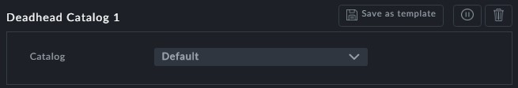

**Points to note:**

**Catalog**: Clicking the Catalog field opens a list of available catalogs:

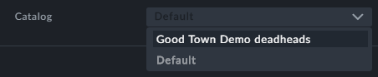

Alternatively, you can enter the name of a catalog by hand. If it does not exist you will be told:

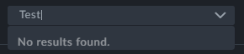

You may also choose Default, to choose the default catalog built into the Dataset, if any



Your chosen catalog will be used at the next and subsequent optimizations



In the absence of a Deadhead Catalog, you can use the **Deadheads Gen-**

**erator** to generate deadheads.